Haldibari-3, Jhapa, Nepal

Estd:2051

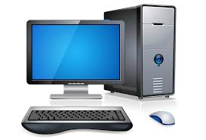

**Project Work Report**

Subject:Computer Science

Topic: Computer System using HTML

**Submitted By: Monika Meche Submitted To: National**

**Nisha Yakha Examination Board (NEB)**

**Dhan Bdr. Karki Bhaktapur, Nepal**

**Subject Teacher: Raju Shrestha Signature:**

**Approved by: Durga M. Gautam Date: 2075/**

**Date: 2075/11/21**

**Acknowledgement**

We would like to express my thanks to the my friends and teacher who have helped me most throughout my project. We are grateful to our subject teacher Raju Shresta and best friend Dhan Bahadur Karki for non-stop support for the project.

A special thank of our goes to my colleague Dhan Bdr Karki , Sagar Ankhewa, Prajwal Puri, Kopila Acharya, Pramila Acharya and others who helped us in completing the project, where they all exchanged their own interesting ideas, thoughts and made this possible to complete our project with all accurate information.

At last but not the least, we want to thank our friends who treasured us for our hard work and encouraged us and finally to God who made all the things possible for us till the end.

Objectives:

The general objective of this project are to:

1. Make student able to make a simple website using web page designing tool like HTML, CSS etc.
2. Provide ideas on how to include subject matter using HTML
3. Enhance designing skill and ideas on Microsoft Office Package like MS-Word.
4. Impart the ways to make a secondary level project

Contents:

**Project 1: Contents of the Project work**

***Markup…………………………………………………….……………………………………………………….***

***Layout……………………………………………………………………………………………………………….***

**Project 2: Component of Computer System**

***Markup…………………………………………………….……………………………………………………….***

***Layout……………………………………………………………………………………………………………….***

**Project 3: Microprocessor**

***Markup……………………………………………………………………………………………………………...***

***Layout………………………………………………………………………………………………………………..***

**Project 4: System Bus**

***Markup…………………………………………………….……………………………………………………….***

***Layout……………………………………………………………………………………………………………….***

**Project 5: Memory**

***Markup…………………………………………………….……………………………………………………….***

***Layout……………………………………………………………………………………………………………….***

**Project 6: Input Device**

***Markup…………………………………………………….……………………………………………………….***

***Layout……………………………………………………………………………………………………………….***

**Project 7: Output Device**

***Markup…………………………………………………….……………………………………………………….***

***Layout……………………………………………………………………………………………………………….***

**Project 8: System Software**

***Markup…………………………………………………….……………………………………………………….***

***Layout……………………………………………………………………………………………………………….***

**Project 9: Application Software**

***Markup…………………………………………………….……………………………………………………….***

***Layout……………………………………………………………………………………………………………….***

**Project 10: Login**

***Markup…………………………………………………….……………………………………………………….***

***Layout………………………………………………………………………………………………………………***

Project 1: Contents of Project work

Markup:

<html>

<head>

<title>Computer</title>

</head>

<body bgcolor="#6666ff">

<center><h1><font color="gold" size=10 face="Algerian"><u>Computer System</u></p></font></h1>

<center><h6><font color="800000" size=6 face="forte"><u>Contents</u></font></h6></center>

<p>

<center><hr size=20 color="#00cc99" width=1350>

<a href="component of computer system.html"><button style=background-color:greenyellow;><b>Component of Computer System</b></button></a><br><br>

<a href="microprocessor.html"><button style=background-color:red;>Microprocessor</button></a><br><br>

<a href="system bus.html"><button style=background-color:blue;>System Bus</button></a><br><br>

<a href="memory.html"><button style=background-color:aqua;><b>Memory</b></button></a><br><br>

<a href="input device.html"><button style=background-color:purple;><b>Input Device</b></button></a><br><br>

<a href="output device.html"><button style=background-color:purple;><b>Output Device</b></button></a><br><br>

<a href="system software.html"><button style=background-color:yellow;><b>System Software</b></button></a><br><br>

<a href="Application Software.html"><button style=background-color:green;><b>Application Software</b></button></a><br><br>

<a href="form.html"><button style=background-color:gray;><b>Login</b></button></a><br><br>

<footer><b>Prepared by:Monika Meche,Nisha Yakha and Dhan Bdr Karki<b></footer>

</body>

</center>

Layout:

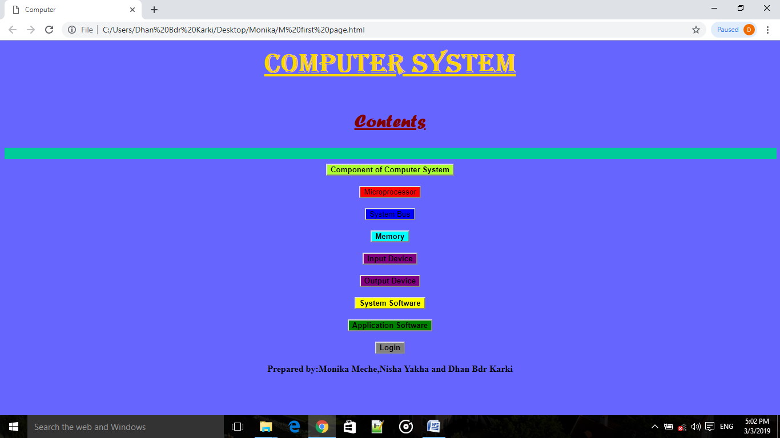

Project 2: Microprocessor

Markup:

<!DOCTYPE html>

<html>

<head>

<style>

h2{

text-align:center;

color:#9966ff;

}

a {

display: inline-block;

border: 1px solid #ddd;

border-radius: 4px;

padding: 5px;

}

a:hover {

box-shadow: 0 0 2px 1px rgba(0, 140, 186, 0.5);

}

</style>

</head>

<body bgcolor=#ff4d4d>

<h2><u width="40px">Microprocessor</u></h2>

<p>A microprocessor is a computer processor that incorporates the functions of a central processing unit on a single integrated circuit (IC), or at most a few integrated circuits. The microprocessor is a multipurpose, clock driven, register based, digital integrated circuit that accepts binary data as input, processes it according to instructions stored in its memory, and provides results as output. Microprocessors contain both combinational logic and sequential digital logic. Microprocessors operate on numbers and symbols represented in the binary number system.</p>

<center><a href="microprocessor.jpg">

<img src="microprocessor.jpg" alt="Microprocessor" width="980" height="360"></a><p><b>Figure:<u>Microprocessor</u></b></center>

<p>Before microprocessors, small computers had been built using racks of circuit boards with many medium- and small-scale integrated circuits. Microprocessors combined this into one or a few large-scale ICs. Continued increases in microprocessor capacity have since rendered other forms of computers almost completely obsolete (see history of computing hardware), with one or more microprocessors used in everything from the smallest embedded systems and handheld devices to the largest mainframes and supercomputers.</p>

</body>

</html>

Layout:

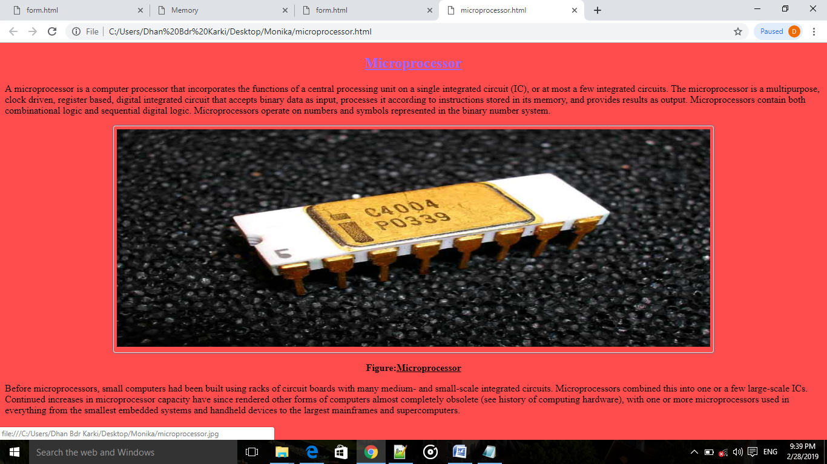

Project 3: System Bus

Markup:

<html>

<head>

<title>

system Buses

</title>

<style>

body{margin-bottom:80px;}

h2{

text-align:center;

font-weight:bold;

}

.box{

margin-bottom:20px;

text-align:center;

}

.box img{

border:1px solid #ff6600;

padding:5px;

background:#ccffe6;

max-width:90%;

}

</style>

</head>

<body>

<div class="one" style="font-size:15px;padding:5px;background:#6666ff;color:#ff1a1a;

font-family:droid sans;margin-bottom:7px;">

<h2>System Buses</h2>

</div>

<div class="box">

<img src="systembus.png" height=360 width=526>

</div>

<div class="two" style="background:#ebefba;padding:10px;font-family:droid sans;font-size:14px;line-height:20px;

color:#555;text-align:justify;color:#000;">

A system bus is a single computer bus that connects the major components of a computer system, combining the functions of a data bus to carry information, an address bus to determine where it should be sent, and a control bus to determine its operation. The components of computer are interacted by the bus. There are different types of bus structure. The bus is a medium used to transfer data, memory address and control signal from one part to other part of computers. There are three types of bus:<ol><li>Data Bus</li><li>Control Bus</li><li>Control Bus</li></ol>

</div>

</body>

</html>

Layout:

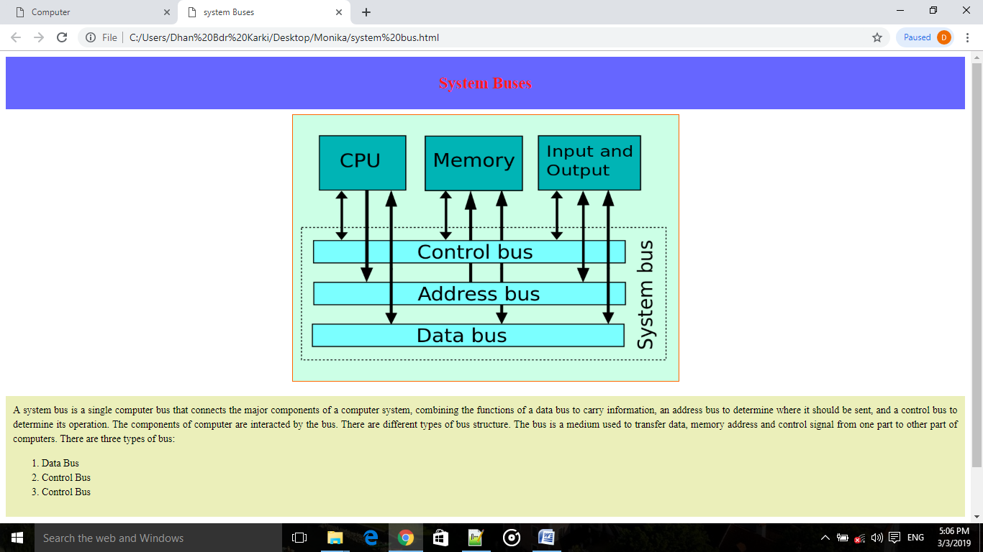

Project 4: Memory

Markup:

<html>

<head>

<title>Memory</title>

<style>

body{

background:red;

margin:0px;

}

h2{

background:green;

color:#fff;

padding:20px;

}

</style>

</head>

<body>

<h2><center>Memory</center></h2>

<p>Memory is the storage device of computer that stores data either permanently or temporarily.Memory is the most essential element of a computing system because without it computer can’t perform simple tasks. Computer memory is of two basic type – Primary memory / Volatile memory and Secondary memory / non-volatile memory. Random Access Memory (RAM) is volatile memory and Read Only Memory (ROM) is non-volatile memory.</p>

<div class="one">

<center><caption>Differences between Primary memory and Secondary Memory</caption> </center>

<table width="50%" border="2" height=20 align=center>

<tr><th>S.n</th>

<th>Primary Memory</th>

<th>S.n</th>

<th>Secondary Memory</th></tr>

<tr>

<td>1.</td>

<td>It is directly connected to the processor.</td>

<td>1.</td>

<td>It is indirectly connected to the processor.</td>

</tr>

<tr>

<td>2.</td>

<td>It is expensive than secondary memory.</td>

<td>2.</td>

<td>It is cheaper than primary memory.</td>

</tr>

<tr>

<td>3.</td>

<td>It has low storage capacity.</td>

<td>3.</td>

<td>It has high storage capacity.</td>

</tr>

<tr>

<td>4.</td>

<td>It is faster than secondary memory.</td>

<td>4.</td>

<td>It is slower than primary memory.</td>

</tr>

<tr>

<td>5.</td>

<td>It is semiconductor memory.</td>

<td>5.</td>

<td>It is optical or secondary memory.</td>

</tr>

<tr>

<td>6.</td>

<td>Examples: RAM, ROM etc.</td>

<td>6.</td>

<td>Examples: hard disk, floopy disk, CD-ROM etc.</td>

</tr>

</table>

</div>

</body>

</html>

Layout:

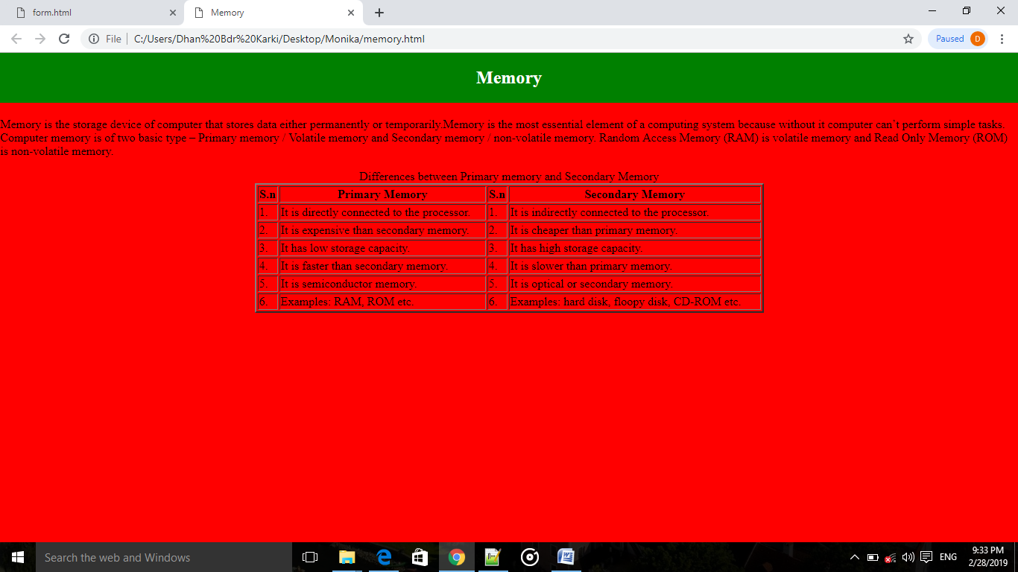

Project 5: Input Devices

Markup:

<html>

<head>

<title>

Input Devices</title>

<style>

body{border:5px solid #669999;padding:10px;}

h1{

background-color:#00ffcc;}

.head{

font-size:30px;

text-decoration: underline;}

.image{

float:right;clear:right;margin-left:10px;margin-bottom:5px;border:3px solid black;height:115;width:200;}

</style>

</head>

<body>

<center><h1><u><b>Input Devices</b></u></h1></center>

<p class="head">Mouse</p>

<img src="mouse.jpg" title=Mouse class="image" style="background-color:#6699ff;">

<p>A computer mouse is a hand-held pointing device that detects two-dimensional motion relative to a surface. This motion is typically translated into the motion of a pointer on a display, which allows a smooth control of the graphical user interface. The first public demonstration of a mouse controlling a computer system was in 1968. Originally wired to a computer, many modern mice are cordless, relying on short-range radio communication with the connected system. Mice originally used a ball rolling on a surface to detect motion, but modern mice often have optical sensors that have no moving parts. In addition to moving a cursor, computer mice have one or more buttons to allow operations such as selection of a menu item on a display. Mice often also feature other elements, such as touch surfaces and "wheels", which enable additional control and dimensional input.</p>

<p class="head"> Light Pen</p>

<img src="light pen.jpg" title=Light Pen class="image">

<p>A light pen is a computer input device in the form of a light-sensitive used in conjunction with a computer€™s CRT TV set or monitor. It allows the used to paint to displayed objects, or draw on the screen, in a similar way to a touch screen but with greater positional accuracy. A light pen can work with any CRT-based display, but not with LCD screens projectors and other display devices. A light pen is fairly simple to implement. Just like a computer light gun, a light pen works by sensing the sudden small change in brightness of a point on the screen when the electro gun refreshes that spot.</p>

<p class="head">Magnetic Ink Character Recognition(MICR)</p>

<img src="micr.jpg" title=MICR class="image">

<p>Magnetic Ink Character Recognition, or MICR, is a character recognition technology used primarily by the banking industry to facilitate the processing of cheques. The technology allows computers to read information off printed documents. Unlike barcodes or similar technologies, however, MICR codes can be easily read by humans. MICR character are printed in special typefaces with a magnetic link or toner, usually containing iron oxide.</p>

</body>

</html>

Layout:

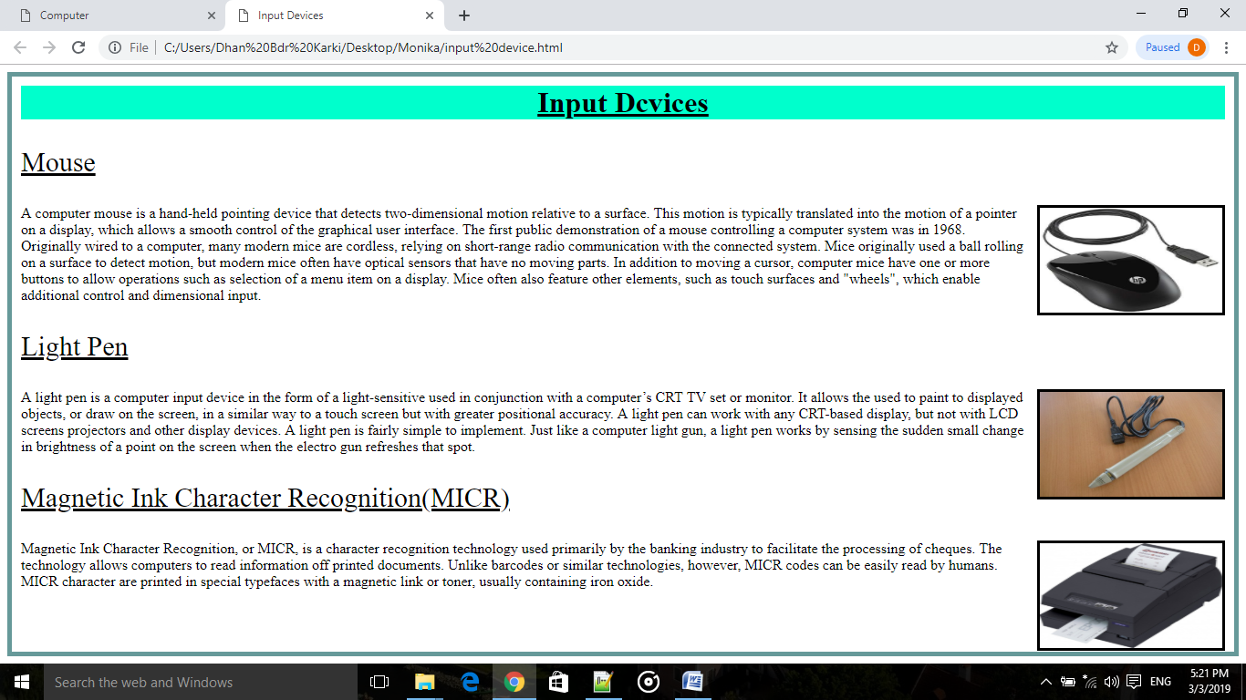

Project 6: Output Devices

Markup:

<html>

<head>

<title>

Output Devices</title>

<style>

body{

border:5px solid #004d3d;

padding:10px;

}

h1{background-color:#66ffe0;}

.head{font-size:30px;text-decoration:underline;margin-left:260px; margin-bottom:-15px;}

.image{float:left;clear:left;margin-right:10px;margin-bottom:5px;border:3px solid black;height:115;width:200;}

</style>

</head>

<body>

<center><h1><u><b>Output Devices</b></u></h1></center>

<p class="head">Monitor</p>

<img src="monitor.jpg" title=Monitor class="image" style="background-color:#6699ff;">

<p>Monitor are output drive of computer. Monitors are used to display any types of data or information in pictorial form from computer. They are soft copy output device. There are different types of monitors such as LCD, CRT etc. A monitor usually comprises the display device, circuitry, casing, and power supply. The display device in modern monitors is typically a thin film transistor liquid crystal display (TFT-LCD) with LED back lighting having replaced cold-cathode fluorescent lamp (CCFL) back lighting. Older monitors used a cathode ray tube (CRT). Monitors are connected to the computer via VGA, Digital Visual Interface (DVI), HDMI, DisplayPort, Thunderbolt, low-voltage differential signaling (LVDS) or other proprietary connectors and signals.

Originally, computer monitors were used for data processing while television receivers were used for entertainment. </p>

<p class="head"> Printer</p>

<img src="printer.jpg" title=Printer class="image">

<p>In computing, a printer is a peripheral device which makes a persistent human-readable representation of graphics or text on paper. The first computer printer designed was a mechanically driven apparatus by Charles Babbage for his difference engine in the 19th century; however, his mechanical printer design was not built until 2000. The first electronic printer was the EP-101, invented by Japanese company Epson and released in 1968.In the 1980s were daisy wheel systems similar to typewriters, line printers that produced similar output but at much higher speed, and dot matrix systems that could mix text and graphics but produced relatively low-quality output. The plotter was used for those requiring high quality line art like blueprints.

<p class="head"> Plotter</p>

<img src="plotter.jpg" title=Plotter class="image">

<p>The plotter is a computer printer for printing vector graphics. Plotters draw pictures on paper using a pen. In the past, plotters were used in applications such as computer-aided design, as they were able to produce line drawings much faster and of a higher quality than contemporary conventional printers, and small desktop plotters were often used for business graphics. Although they retained a niche for producing very large drawings for many years, plotters have now largely been replaced by wide-format conventional printers.</p>

<p class="head"> Speaker</p>

<img src="speaker.jpg" title=Speaker class="image">

<p>Computer speakers, or multimedia speakers, are speakers sold for use with computers, although usually capable of other audio uses, e.g. for an MP3 player. Most such speakers have an internal amplifier and consequently require a power source, which may be by a mains power supply often via an AC adapter, batteries, or a USB port (able to supply no more than 2.5W DC, 500mA at 5V). The signal input connector is often a 3.5 mm jack plug (usually color-coded lime green per the PC 99 standard); RCA connectors are sometimes used, and a USB port may supply both signal and power (requiring additional circuitry, and only suitable for use with a computer). Battery-powered wireless Bluetooth speakers require no connections at all.</p>

</body>

</html>

Layout:

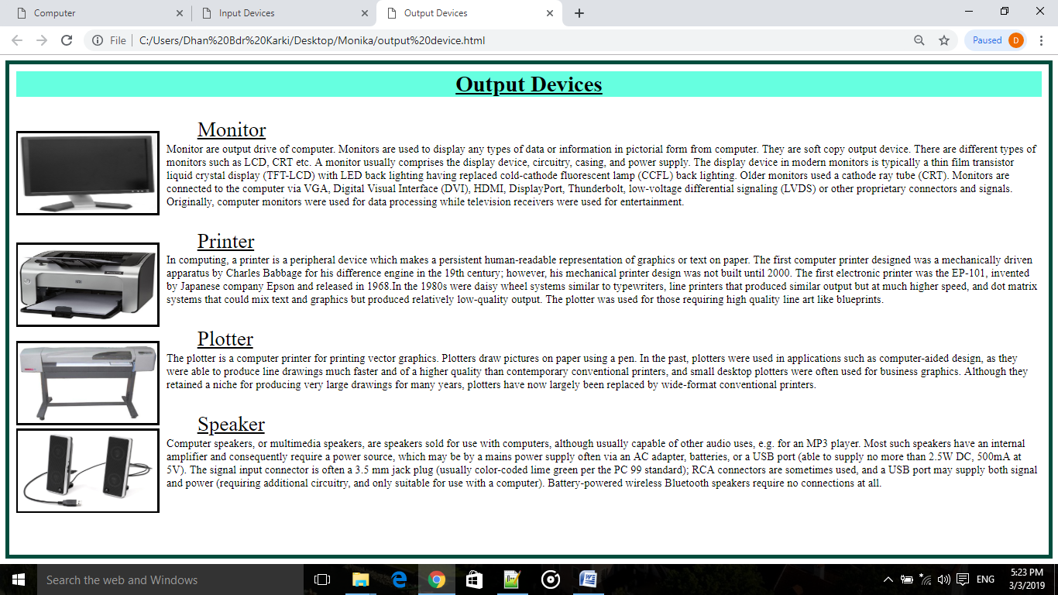

Project 7: System Software

Markup:

<html>

<head>

</head>

<style>

#header {

background-color:black;color:white;text-align:center;padding:5px;}

#nav {line-height:30px;background-color:#eeeeee;height:495px;width:200px;float:left;padding:5px;margin-right:10px;border:none;}

ul {list-style-type: none;margin: 0;padding: 0;width: 200px;background-color: #f1f1f1;border: 1px solid #555;}

li a {display: block;color: #000;padding: 8px 16px;text-decoration: none;}

li {text-align: center;border-bottom: 1px solid #555;}

li:last-child {border-bottom: none;}

li a.dbk {background-color: #4CAF50;color: white;}

li a:hover:not(.dbk) {background-color: #555;color: white;}

.one{margin-top:10px;padding:5px;margin-left:2.25in;border:2px solid red;}

</style>

</head>

<body>

<div id="header">

<h1>Software</h1>

<p> Software refers to parts of the computer which do not have a material form, such as programs, data, protocols etc. Software refers to something intangible. Basically, software is a program, written by a programmer which controls specific parts of computer or specific application.</p>

</div>

<div id="nav">

<ul>

<li><a class="dbk" href="#Types of Software">Types of Software</a></li>

<li><a href="System Software.html">System Software</a></li>

<li><a href="Application software.html">Application Software</a></li>

<li><a href="Utility Software.html">Utility Software</a></li>

</ul>

</div>

<div class="one">

<h2>System Software</h2>

<p>System Software is the software that is directly related to coordinating computer operations and performs tasks associated with controlling and utilizing computer hardware. These programs assist in running application programs and are designed to control the operation of a computer system. System software directs the computer what to do, when to do and how to do. System software can be further categorized into two types:

<h2><u>1.Operating System</u></h2>

<p>An Operating system is the most important system software. It is a set of programs that control and supervise the hardware of a computer and also provide services to application software, programmers and users. It manages all hardware and software, input, output and processing activities within the computer system, the flow of information to and from the processor, sets priorities for handling different tasks, and so on.Some of the popular operating systems used in personal computers are DOS, Windows, Unix, Linux, Solaris, etc. </p><br>

<h2><u>2.Language Translator</u></h2>

<p>We know that computer understands instructions in machine code, i.e. in the form of 0s and 1s.A program written in any high-level programming language (or written in assembly language) is called the Source Program or Source Code. The source code cannot be executed directly by the computer. The source code must be converted into machine language to be executed. The program translated into machine code is known as Object Program or Object code. The special translator system software that is used to translate the program written in high-level language (or Assembly language) into machine code is called language processor or translator program. The language processors can be any of the following three types- Assembler, Compiler and Interpreter. </p>

</div>

</div>

</head>

</html>

Layout:

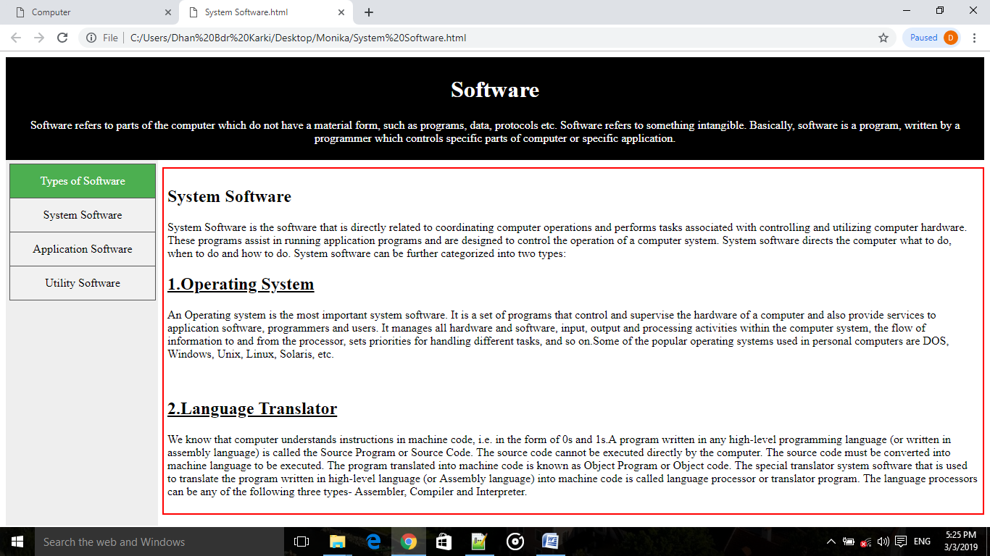

Project 7: Application Software

Markup:

<html>

<head>

<style>

#header {background-color:black;color:white;text-align:center;adding:5px;}

#nav {line-height:30px;background-color:#eeeeee;height:495px;width:200px;float:left;padding:5px;margin-right:10px;border:none; }

ul {list-style-type: none;margin: 0;padding: 0;width: 200px;background-color: #f1f1f1;border: 1px solid #555;}

li a {display: block;color: #000;padding: 8px 16px;text-decoration: none;}

li {text-align: center;border-bottom: 1px solid #555;}

li:last-child {border-bottom: none;}

li a.dbk {background-color: #4CAF50;color: white;}

li a:hover:not(.dbk) {background-color: #555;color: white;}

</style>

</head>

<body>

<div id="header">

<h1>Software</h1>

<p>A set of programs that form an interface between the hardware and the user of a computer system are referred to as Software. Information stored on computer hardware is often called software.The software components of a computer system are the data and the computer programs.</p>

</div>

<div id="nav">

<ul>

<li><a class="dbk" href="#Types of Software">Types of Software</a></li>

<li><a href="System Software.html">System Software</a></li>

<li><a href="Application software.html">Application Software</a></li>

<li><a href="Utility Software.html">Utility Software</a></li>

</ul>

</div>

<h2><mark>Application Software</mark></h2>

<p>An application software is bought by the user to perform specific applications or tasks, say for example making a document or making a presentation or handling inventory or managing the employee database. It enables the user to accomplish certain specific tasks. It utilizes the capacities of a computer directly to a dedicated task. It is able to manipulate the text, numbers and graphics. It can be in the form of software focused on a certain single task like word processing, spreadsheet or playing of audio and video files. Application software can be of two types – General Purpose Application Software and Customized Application software.

<h2><u>1.Package Software</u></h2>

Some of the application software is made for the common users for day to day applications and uses. These are also referred as Office Tools. The users may use them in the manner they want. Some of the popular types of package software are: word processing software, database software, spreadsheet software etc.</p><br>

<h2><u>2.Tailored Software</u></h2>

<p>Tailored Software is one which is tailor made as per the user’s requirement. Such type of software is customer specific. It is made keeping in mind the individual needs of the user and so are also referred as Domain Specific Tools. Such software cannot be installed and used by any other user/customer since the requirements may differ. Some of the popular types of tailored software are: banking software, hospital software etc.</p>`

</head>

</html>

Layout:

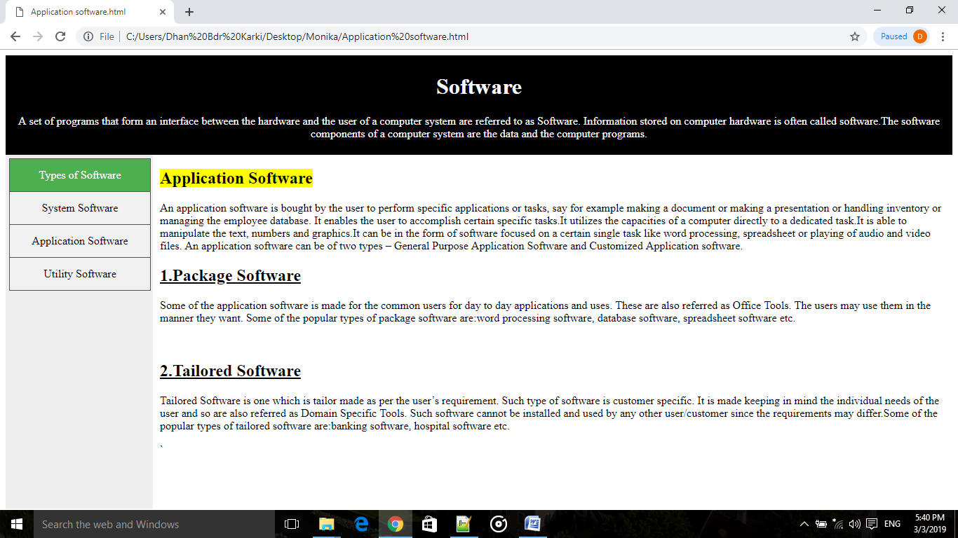

(Similarly, we can prepare on “Utility software”)

Project 8: Simple type of Form

Markup:

<!DOCTYPE html>

<html>

<style>

input[type=text], select {width: 100%;padding: 12px 20px;margin: 8px 0;display: inline-block;border: 1px solid #ccc;border-radius: 4px;box-sizing: border-box;}

input[type=submit] {width: 100%;background-color: #4CAF50;color: white;padding: 14px 20px;margin: 8px 0;border: none;}

input[type=submit]:hover {background-color: #45a049;}

div {border-radius: 5px;background-color: #f2f2f2;padding: 40px;}

</style>

<body>

<h3>Simple form using CSS</h3>

<div>

<form action="http://www.duckduckgo.com">

<label for="fname">First Name</label>

<input type="text" id="fname" placeholder="First Word of your name" name="firstname">

<label for="lname">Last Name</label>

<input type="text" id="lname" placeholder="Last Word of your name" name="lastname">

<labelfor="gender">Gender</label>

<select>

<option >Male</option>

<option>Female</option>

<option>Others</option>

</select>

<label for="country">Country</label>

<select id="Country" name="Country">

<option value="Nepal">Nepal</option>

<option value="China">China</option>

<option value="usa">USA</option>

<option value="Austraila">Australia</option>

<option value="India">India</option>

</select>

<input type="submit" value="Submit">

</form>

</div>

</body>

</html>

Layout:

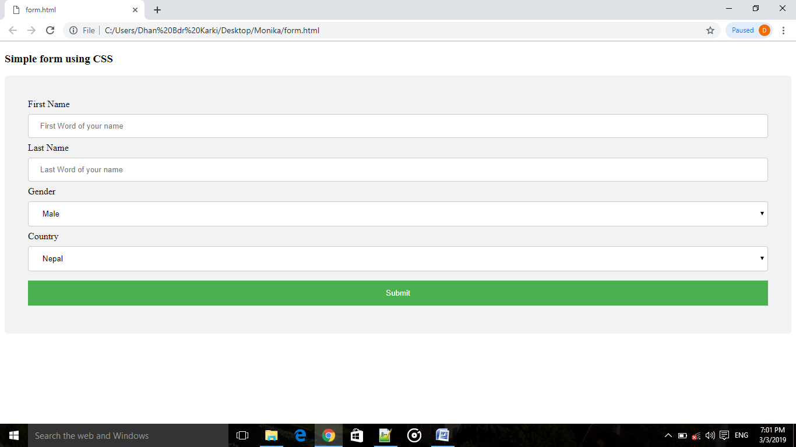

Conclusion

That’s all about my project. The first project that I have been doing based on HTML comes to an end. This is an unforgettable experience that I have got while i have been undergoing through this project. All the HTML based codes presented in this project has been written by me independently while i was helped by the W3school and Class 11 computer book for creative ideas and revise of the lesson.

The project solely focuses on the basic use of HTML for webpage creation. It contains useful information for class 11 students about the components of computer system, different types of software and simple type of form designing which can be referenced and relied upon when in need.

This project would have been never completed without the use of Windows based application such as Notepad++, MS Word, and Wikipedia etc. This project is very useful and can also fulfil small portion of computer notes which we require for the academic results.

Bibliography

* Computer Science grade XI
* Google
* Wikipedia
* W3schools